**PRACTICAL NO.10**

**Write the program for the following:**

a. Create a web application to demonstrate JS Bootstrap Button.

**Code:**

**Aspx code:**

<%@ Page Language="C#" AutoEventWireup="true" CodeBehind="WebForm1.aspx.cs" Inherits="bootstrappract10.WebForm1" %>

<!DOCTYPE html>

<html xmlns="http://www.w3.org/1999/xhtml">

<head runat="server">

<title>My bootstrap application</title>

<link href="https://cdn.jsdelivr.net/npm/bootstrap@5.3.3/dist/css/bootstrap.min.css" rel="stylesheet" integrity="sha384-QWTKZyjpPEjISv5WaRU9OFeRpok6YctnYmDr5pNlyT2bRjXh0JMhjY6hW+ALEwIH" crossorigin="anonymous" />

</head>

<body>

<form id="form1" runat="server">

<div class="container mt-4">

<div class="row mb-3">

<div class="col-md-6">

<asp:Label ID="Label1" runat="server" Text="Number 1 : " CssClass="form-label"></asp:Label>

<asp:TextBox ID="TextBox1" runat="server" CssClass="form-control"></asp:TextBox>

</div>

</div>

<div class="row mb-3">

<div class="col-md-6">

<asp:Label ID="Label2" runat="server" Text="number 2 : " CssClass="form-label"></asp:Label>

<asp:TextBox ID="TextBox2" runat="server" CssClass="form-control"></asp:TextBox>

</div>

</div>

<div class="row mb-3">

<div class="col-md-6">

<asp:Button ID="Button1" runat="server" Text="Addition" CssClass="btn btn-primary" OnClick="Button1_Click" />

<asp:Button ID="Button2" runat="server" Text="subtraction" CssClass="btn btn-secondary" OnClick="Button2_Click"/>

<asp:Button ID="Button3" runat="server" Text="multiplication" CssClass="btn btn-success" OnClick="Button3_Click" />

<asp:Button ID="Button4" runat="server" Text="division" CssClass="btn btn-danger" OnClick="Button4_Click"/>

</div>

</div>

<div class="row mb-3">

<div class="col-md-6">

<asp:Label ID="Label3" runat="server" Text="" CssClass="form-label fw-bold"></asp:Label>

</div>

</div>

</div>

</form>

</body>

</html>

**C# code:**

using System;

using System.Collections.Generic;

using System.Linq;

using System.Web;

using System.Web.UI;

using System.Web.UI.WebControls;

namespace bootstrappract10

{

public partial class WebForm1 : System.Web.UI.Page

{

protected void Page_Load(object sender, EventArgs e)

{

}

int num1=0;

int num2=0;

int result;

protected void Button1_Click(object sender, EventArgs e)

{

num1 = Convert.ToInt16(TextBox1.Text);

num2 = Convert.ToInt16(TextBox2.Text);

result = num1 + num2;

Label3.Text = "Addition is " + result;

}

protected void Button2_Click(object sender, EventArgs e)

{

num1 = Convert.ToInt16(TextBox1.Text);

num2 = Convert.ToInt16(TextBox2.Text);

result = num1 - num2;

Label3.Text = "Subtraction is " + result;

}

protected void Button3_Click(object sender, EventArgs e)

{

num1 = Convert.ToInt16(TextBox1.Text);

num2 = Convert.ToInt16(TextBox2.Text);

result = num1 * num2;

Label3.Text = "Multiplication is " + result;

}

protected void Button4_Click(object sender, EventArgs e)

{

num1 = Convert.ToInt16(TextBox1.Text);

num2 = Convert.ToInt16(TextBox2.Text);

result = num1 / num2;

Label3.Text = "Division is " + result;

}

}

}

**Output:**

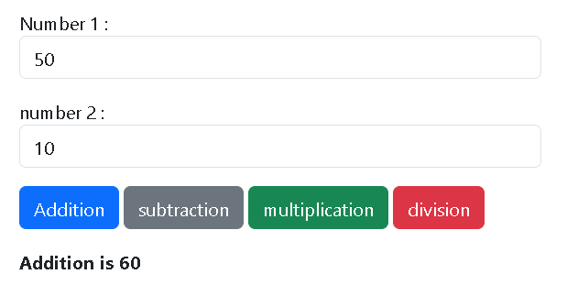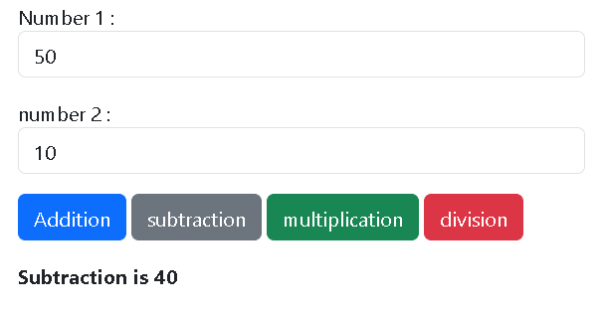

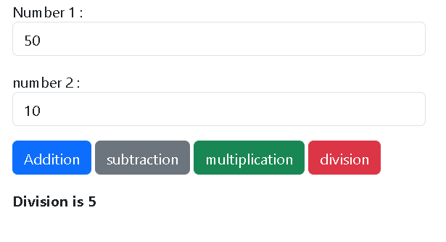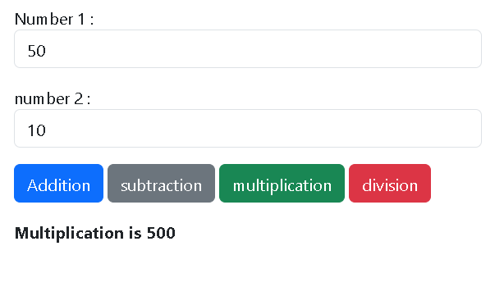

b. Create a web application to demonstrate use of various Ajax controls.

**Code:**

**Aspx code:**

<%@ Page Language="C#" AutoEventWireup="true" CodeBehind="WebForm1.aspx.cs" Inherits="ajaxpract10.WebForm1" %>

<!DOCTYPE html>

<html xmlns="http://www.w3.org/1999/xhtml">

<head runat="server">

<title></title>

<style type="text/css">

.auto-style1 {

position: absolute;

top: 133px;

left: 586px;

z-index: 1;

}

.auto-style2 {

position: absolute;

top: 140px;

left: 441px;

z-index: 1;

}

.auto-style3 {

position: absolute;

top: 107px;

left: 407px;

z-index: 1;

}

.auto-style4 {

position: absolute;

top: 109px;

left: 275px;

z-index: 1;

}

.auto-style5 {

position: absolute;

top: 217px;

left: 373px;

z-index: 1;

height: 33px;

width: 156px;

}

</style>

</head>

<body>

<form id="form1" runat="server">

<div>

<asp:ScriptManager ID="ScriptManager1" runat="server">

</asp:ScriptManager>

<asp:UpdatePanel ID="UpdatePanel1" runat="server">

<ContentTemplate>

<asp:Label ID="Label1" runat="server" CssClass="auto-style1"></asp:Label>

<br />

<br />

<asp:Timer ID="Timer1" runat="server" Interval="5000">

</asp:Timer>

<asp:TextBox ID="TextBox1" runat="server" CssClass="auto-style3"></asp:TextBox>

<asp:Label ID="Label2" runat="server" CssClass="auto-style4" Text="enter word &quot;SRM&quot;"></asp:Label>

<asp:Button ID="Button1" runat="server" CssClass="auto-style2" OnClick="Button1_Click" Text="submit" />

<br />

<br />

</ContentTemplate>

</asp:UpdatePanel>

</div>

<asp:UpdateProgress ID="UpdateProgress1" runat="server">

<ProgressTemplate>

<br />

<br />

<br />

<asp:Label ID="Label3" runat="server" CssClass="auto-style5" Text="successfully entered"></asp:Label>

</ProgressTemplate>

</asp:UpdateProgress>

</form>

</body>

</html>

**C# code:**

using System;

using System.Collections.Generic;

using System.Linq;

using System.Web;

using System.Web.UI;

using System.Web.UI.WebControls;

namespace ajaxpract10

{

public partial class WebForm1 : System.Web.UI.Page

{

protected void Page_Load(object sender, EventArgs e)

{

Label1.Text = DateTime.Now.ToString();

}

protected void Button1_Click(object sender, EventArgs e)

{

if(TextBox1.Text=="SRM")

{

System.Threading.Thread.Sleep(3000);

}

}

}

}

**Output:**

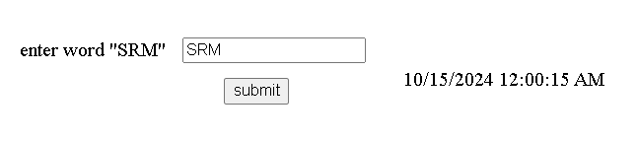

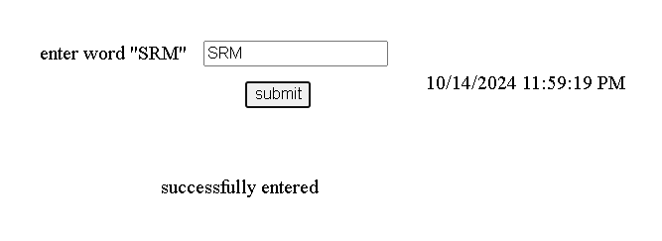

c. Create a web application to demonstrate Installation and use of NuGet package.

**Installation NuGet package (Humanizer):**

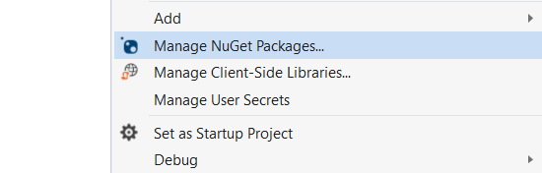

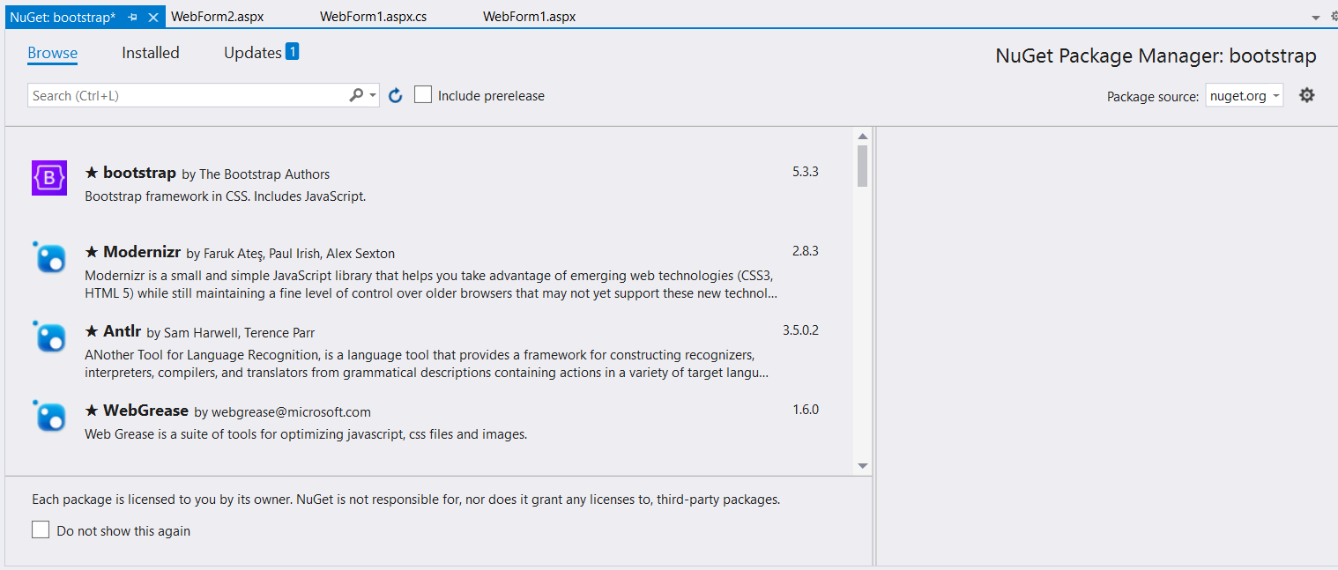

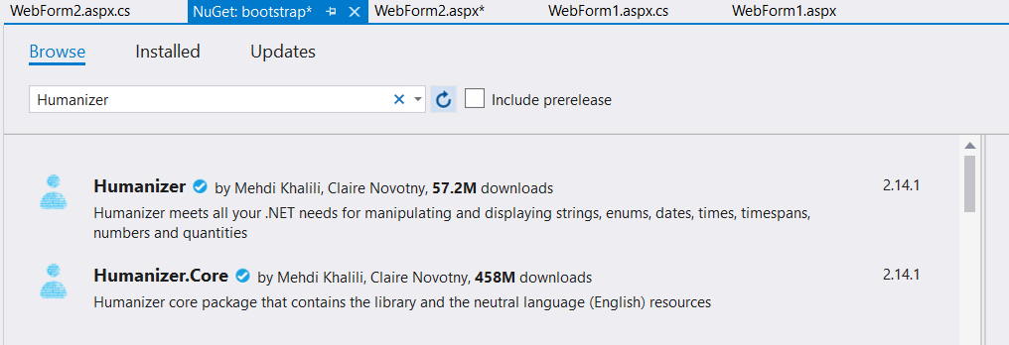

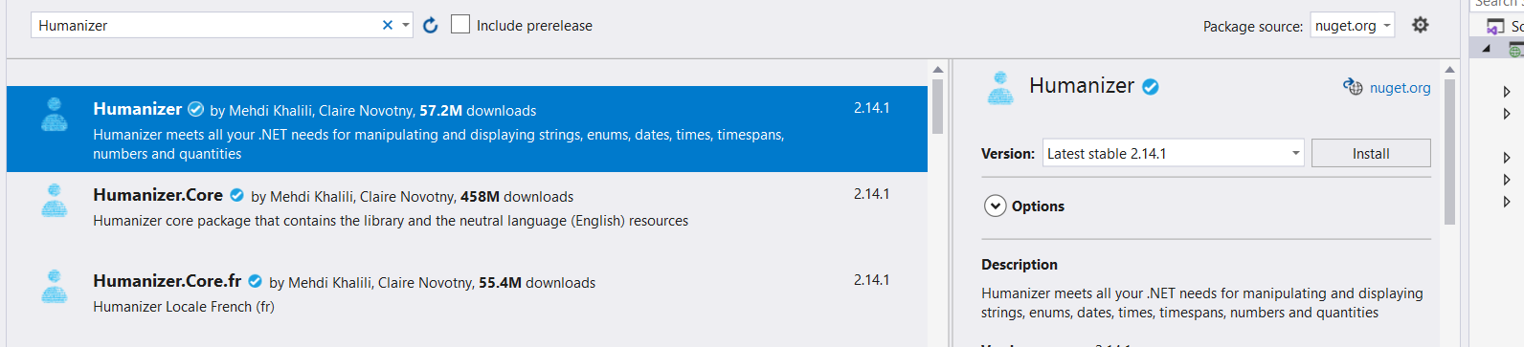

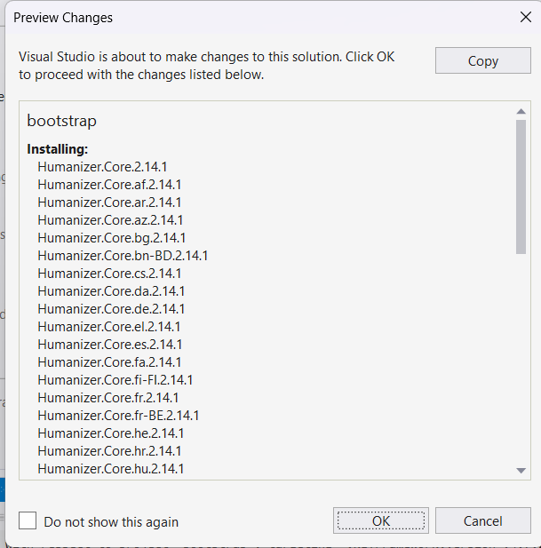

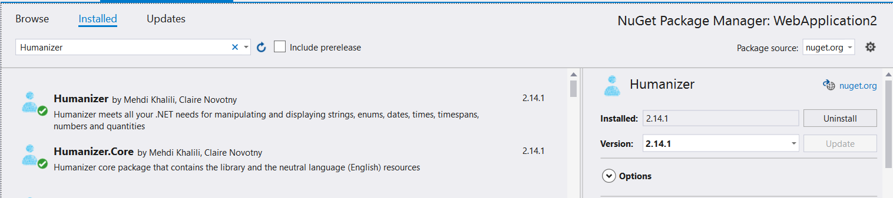

**Code:**

**Aspx code :**

<%@ Page Language="C#" AutoEventWireup="true" CodeBehind="WebForm1.aspx.cs" Inherits="nugetpackage.WebForm1" %>

<!DOCTYPE html>

<html xmlns="http://www.w3.org/1999/xhtml">

<head runat="server">

<title></title>

<style type="text/css">

.auto-style1 {

height: 397px;

width: 1024px;

position: absolute;

top: 15px;

left: 10px;

}

.auto-style2 {

position: absolute;

top: 31px;

left: 320px;

z-index: 1;

width: 310px;

height: 33px;

}

.auto-style3 {

position: absolute;

top: 101px;

left: 317px;

z-index: 1;

height: 26px;

}

.auto-style4 {

position: absolute;

top: 99px;

left: 474px;

z-index: 1;

height: 26px;

width: 147px;

}

.auto-style5 {

position: absolute;

top: 157px;

left: 431px;

z-index: 1;

}

.auto-style6 {

position: absolute;

top: 216px;

left: 433px;

z-index: 1;

}

</style>

</head>

<body>

<form id="form1" runat="server">

<div class="auto-style1" style="z-index: 1">

<asp:Label ID="Label1" runat="server" BorderStyle="Solid" CssClass="auto-style2" Font-Size="X-Large" Text="nuget pacakge (Humanizer)"></asp:Label>

<asp:Label ID="Label2" runat="server" CssClass="auto-style3" Text="enter the miliseconds : "></asp:Label>

<asp:TextBox ID="TextBox1" runat="server" CssClass="auto-style4"></asp:TextBox>

<asp:Button ID="Button1" runat="server" CssClass="auto-style5" OnClick="Button1_Click" Text="click" />

<asp:Label ID="Label3" runat="server" CssClass="auto-style6"></asp:Label>

</div>

</form>

</body>

</html>

**C# Code :**

using System;

using System.Collections.Generic;

using System.Linq;

using System.Web;

using System.Web.UI;

using System.Web.UI.WebControls;

using Humanizer;

namespace nugetpackage

{

public partial class WebForm1 : System.Web.UI.Page

{

protected void Page_Load(object sender, EventArgs e)

{

}

protected void Button1_Click(object sender, EventArgs e)

{

double num = Convert.ToDouble(TextBox1.Text);

Label3.Text = "time : " + TimeSpan.FromMilliseconds(num).Humanize(4);

}

}

}

**Output:**

